**Course: Theory of Automata(CS301) Exam: Mock**

**Max. Marks: 05 Section___**

**Date: June 16, 2020 Time Allowed: 40 Mins**

**Student ID:__________________ Student Name:___________________**

**Q1.** Run a string on the given machine and find the output. The input string is the digit part of your ID e.g. 1315 if ID is K18-1315. You have to first convert your id into string of 0's and 1's. The digit 1 in your ID remains 1and all other digits would convert into 0's.

**Example:**

Actual ID: K18-1315

After conversion: 1010

**Attempt following:**

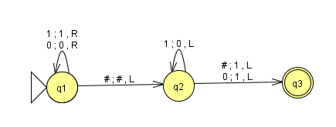

a. What is the function of the above Turing machine. (*Hint: you can run more strings, so that to understand the function*)

b. Encode the above Turing machine as used in Universal Turing machine